USER MANUAL

How to deliver data through Reportnet under Article 22/Annex XI of the MMR Policies or Measures (PAMs)

(EU) No 749/2014

These guidelines explain how to use the electronic infrastructure for reporting information to the European Commission in pursuance of Article 1/Annex I of the IED Implementing Decision (2012/795/EU).

**How to deliver**

All deliveries are provided via the Reportnet Central Data Repository (CDR), which is maintained by

the European Environment Agency (EEA).

**Summary of the delivery process**

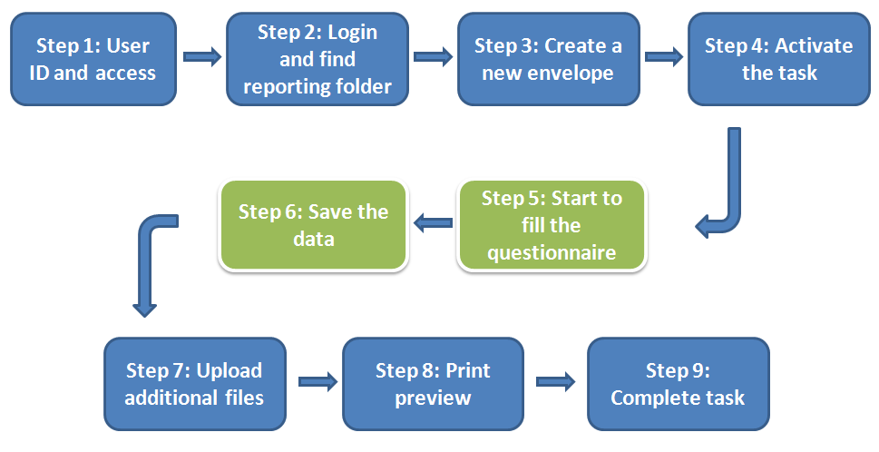

* **Step 1: User accounts and access permissions**

In order to report, an Eionet account with user name and password is required as well as permission to upload the national delivery. Please inform DG Environment and EEA about who will be the person(s) responsible for the reporting, so that the necessary arrangements can be made. The person(s) who do not yet have an EIONET account will receive an e-mail with their EOINET login and password. All persons nominated as reporter will receive upload rights to the CDR. Only new reporters will receive a notification on this from the Eionet Helpdesk ([helpdesk@eionet.europa.eu](mailto:helpdesk@eionet.europa.eu)).

* **Step 2: Login to the Central Data Repository and open your folder**

You can access EEA’s Central Data Repository (CDR) at [http://cdr.eionet.europa.eu](http://cdr.eionet.europa.eu/)

When preparing for the MMR Annex XI questionnaire delivery, you first have to log in by using your Eionet user name and password and then navigate to the respective folder of you country (see the links below).

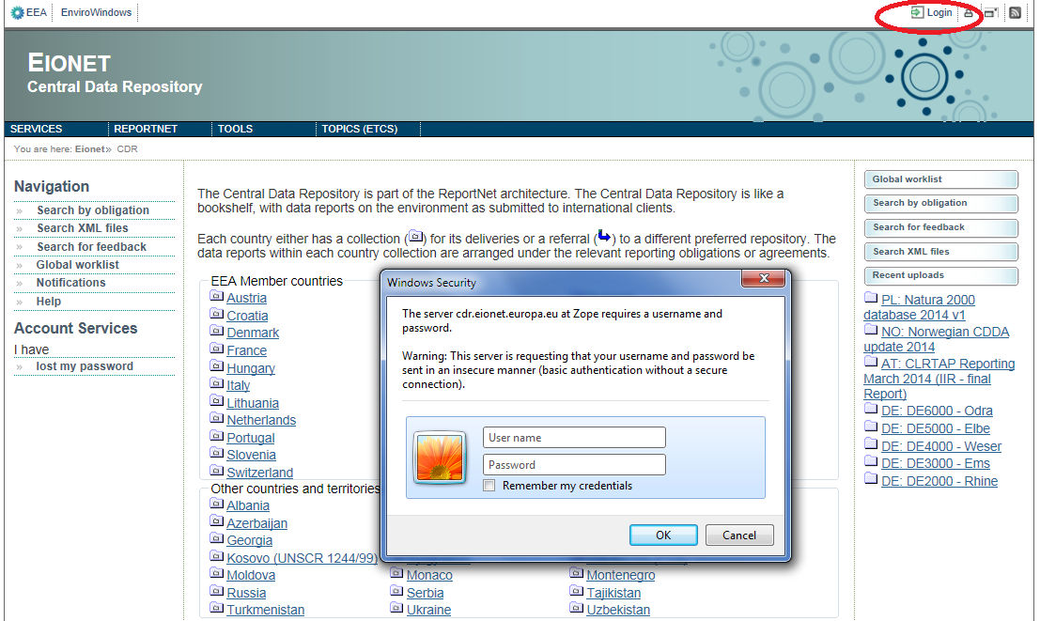

Country URL to "MMR Annex XI questionnaire" reporting folder

|  |  |  |
| --- | --- | --- |
| **Country** | | **IED Annex I reporting deliveries to CDR** |
| **Name** | **ISO** | **Hyperlink to national folder** |
| Austria  Belgium  Bulgaria  Croatia  Cyprus  Czech Republic  Denmark  Estonia  Finland  France  Germany  Greece  Hungary  Iceland  Ireland  Italy  Latvia  Liechtenstein  Lithuania  Luxembourg  Malta  Netherlands  Norway  Poland  Portugal  Romania  Slovakia  Slovenia  Spain  Sweden  United Kingdom | AT  BE  BG  HR  CY  CZ  DK  EE  FI  FR  DE  GR  HU  IS  IE  IT  LV  LI  LT  LU  MT  NL  NO  PL  PT  RO  SK  SI  ES  SE  UK | <http://cdr.eionet.europa.eu/at/eu/ied/annex1>  <http://cdr.eionet.europa.eu/be/eu/ied/annex1>  <http://cdr.eionet.europa.eu/bg/eu/ied/annex1>  <http://cdr.eionet.europa.eu/hr/eu/ied/annex1>  <http://cdr.eionet.europa.eu/cy/eu/ied/annex1>  <http://cdr.eionet.europa.eu/cz/eu/ied/annex1>  <http://cdr.eionet.europa.eu/dk/eu/ied/annex1>  <http://cdr.eionet.europa.eu/ee/eu/ied/annex1>  <http://cdr.eionet.europa.eu/fi/eu/ied/annex1>  <http://cdr.eionet.europa.eu/fr/eu/ied/annex1>  <http://cdr.eionet.europa.eu/de/eu/ied/annex1>  <http://cdr.eionet.europa.eu/gr/eu/ied/annex1>  <http://cdr.eionet.europa.eu/hu/eu/ied/annex1>  <http://cdr.eionet.europa.eu/is/eu/ied/annex1>  <http://cdr.eionet.europa.eu/ie/eu/ied/annex1>  <http://cdr.eionet.europa.eu/it/eu/ied/annex1>  <http://cdr.eionet.europa.eu/lv/eu/ied/annex1>  <http://cdr.eionet.europa.eu/li/eu/ied/annex1>  <http://cdr.eionet.europa.eu/lt/eu/ied/annex1>  <http://cdr.eionet.europa.eu/lu/eu/ied/annex1>  <http://cdr.eionet.europa.eu/mt/eu/ied/annex1>  <http://cdr.eionet.europa.eu/nl/eu/ied/annex1>  <http://cdr.eionet.europa.eu/no/eu/ied/annex1>  <http://cdr.eionet.europa.eu/pl/eu/ied/annex1>  <http://cdr.eionet.europa.eu/pt/eu/ied/annex1>  <http://cdr.eionet.europa.eu/ro/eu/ied/annex1>  <http://cdr.eionet.europa.eu/sk/eu/ied/annex1>  <http://cdr.eionet.europa.eu/si/eu/ied/annex1>  <http://cdr.eionet.europa.eu/es/eu/ied/annex1>  <http://cdr.eionet.europa.eu/se/eu/ied/annex1>  <http://cdr.eionet.europa.eu/gb/eu/ied/annex1> |

* **Step 3: Create a new envelope**

Now **create a new envelope** which will contain your data delivery by clicking on the button ‘New envelope’ at the upper right corner of the screen:

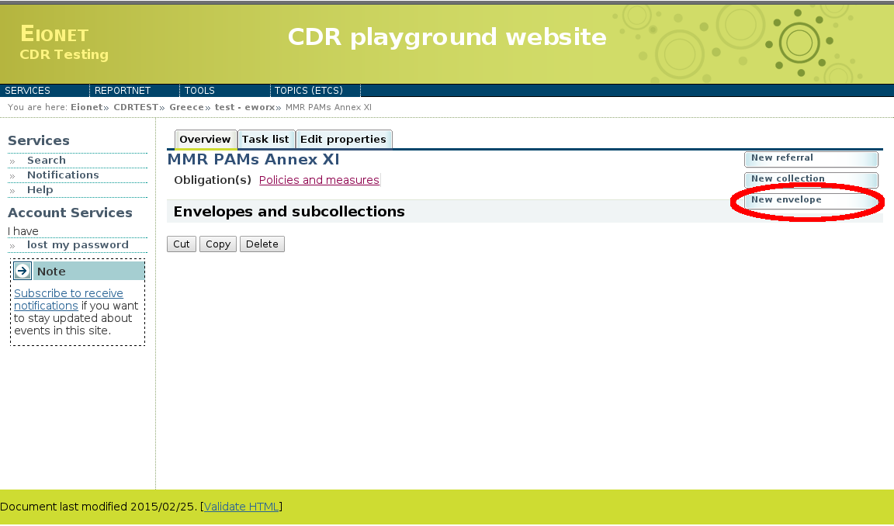

# Provide meaningful metadata about your delivery on the “Add Envelope” page. At least “Title” and “Relating to which year” fields have to be filled in.

# The Envelope title should briefly summarise the delivery by providing the information about the reporting country, obligation and year. Then it will be easier for the reporter and other stakeholders to find the delivery. “Relating to which year” indicates the period the report will cover. The report to be delivered in March 2015 is for the year 2014.

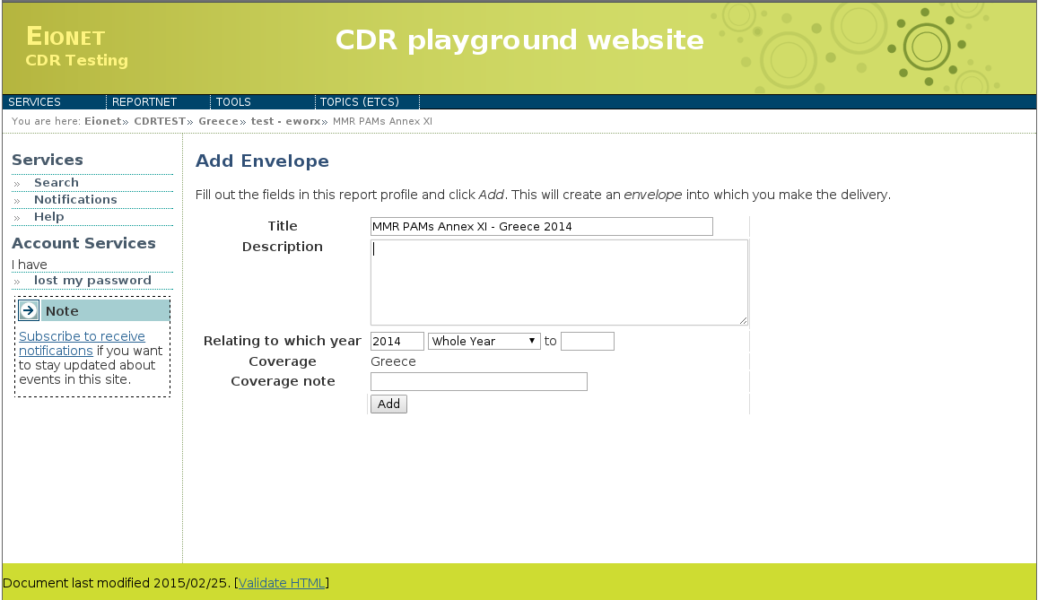

After clicking "Add" button the envelope is created and listed in the MMR Annex XI reporting folder.

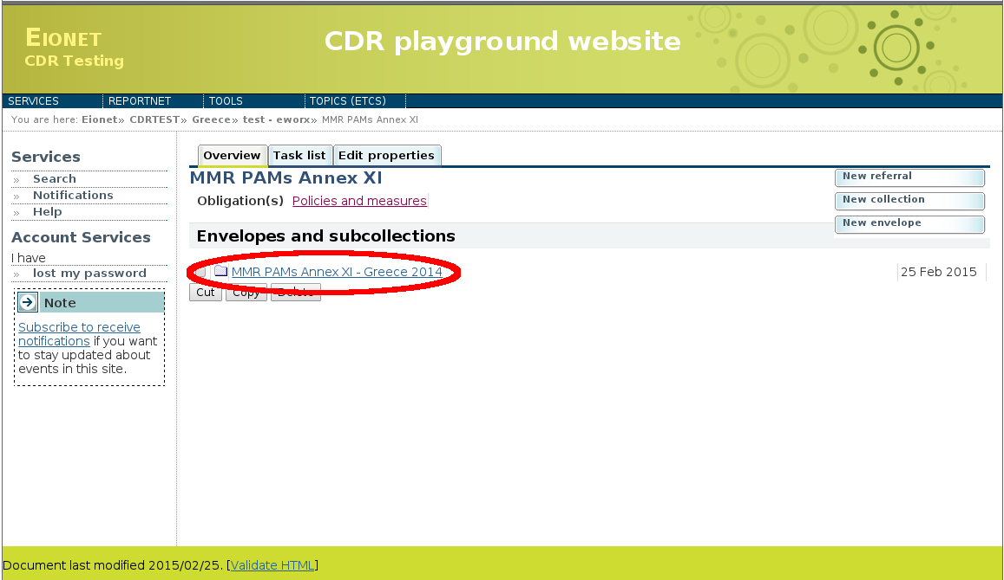

* **Step 4: Activate the task**

The way to start the work in the envelope is to enter the envelope by clicking on the envelope name and activate the **Draft** task by clicking on the <*Activate task: Draft*> link or by pressing the <*Activate task*> button.

Activating means that you have reserved the envelope for yourself to work on. Other users will not be able to modify it until the envelope is deactivated or released. Your new envelope is now in Draft status and files can be added.

* **Step 5 Start to fill out the online questionnaire**

The next step is to fill in your report by using the online questionnaire, which can be achieved by clicking on the link on top of the envelope:

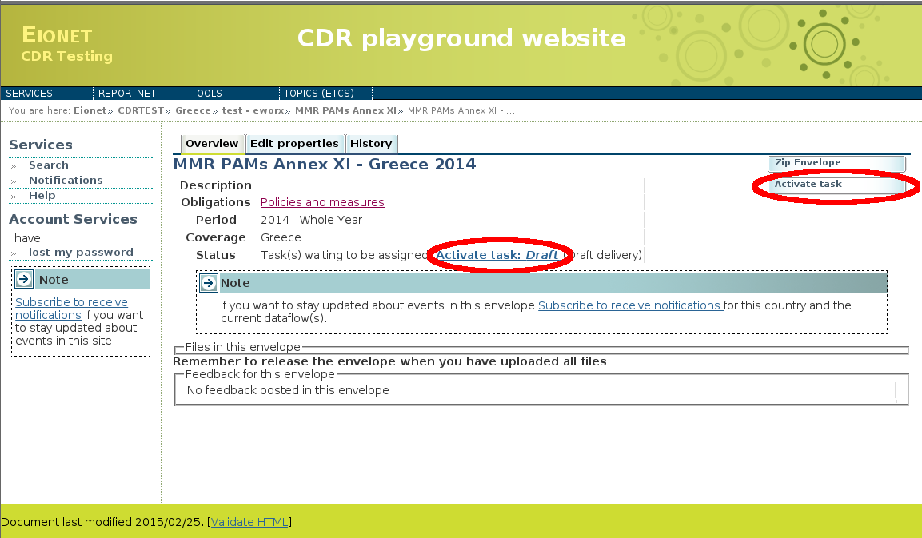

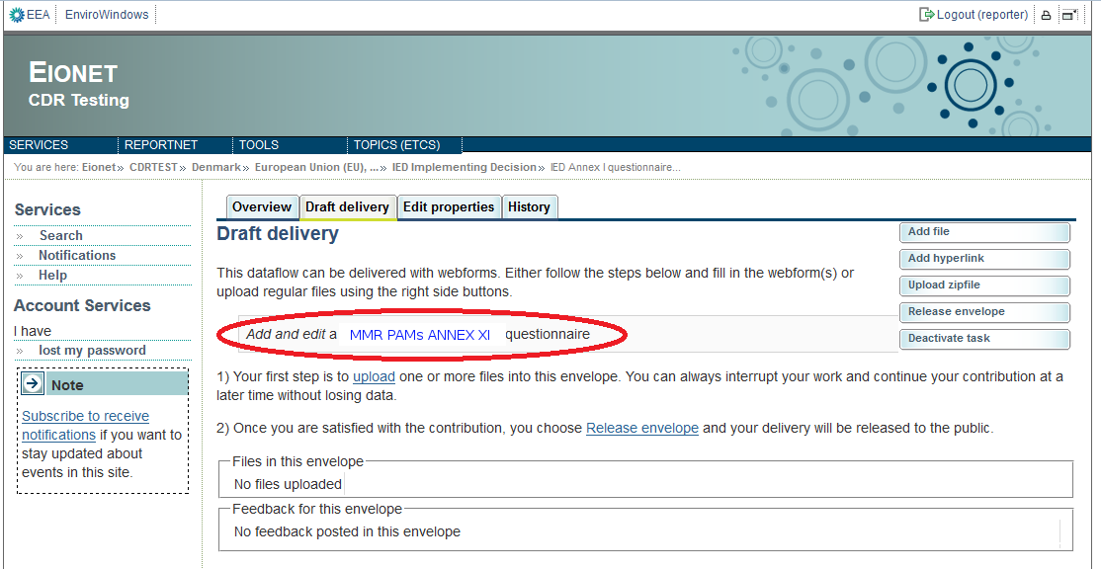It takes some seconds to load up the questionnaire. After opening the questionnaire you will see the following screen:

**General principles of using the online questionnaire**

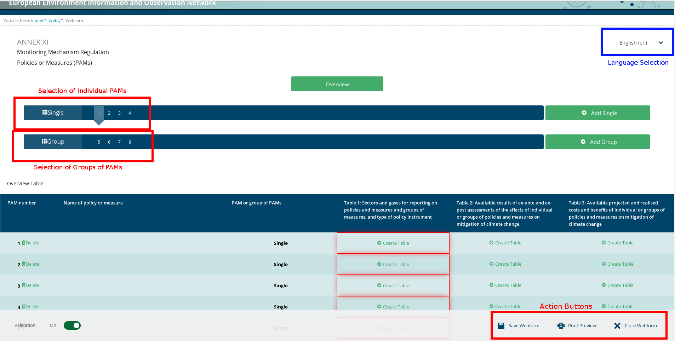The questionnaire has a top navigation bar that includes all of the Policies or Measures (PAMs) and group of PAMs.It is also divided into 4 Tables (Overview, Table 1, Table2, Table 3) and it has common areas which are always visible.

**Navigation**

**-** To add a new PAM or Group of PAMs click on the button next to the **top navigation bar** with label “Add Single” to add an individual PAM or “Add Group” to add a Group of PAMs

**-** To view or edit a different PAM or Group of PAMs click on the number of PAM at the **top navigation bar.**

* All the forms are accessible from the (tabs) below the **top navigation bar**. The active form tab is displayed as a small cloud with a light blue color.
* The **bottom navigation bar** under the reporting form contains links to **save** and **print preview**. You can also disable validation by clicking the **validation switch**. If Validation is enabled, the switch will have a green color to indicate it is selected.

**Tables and Buttons**

**Overview** – Overview of every PAM or Group of PAMs and validation information about each table.

* **Table 1** – Sectors and gases for reporting on policies and measures and groups of measures, and type of policy instrument
* **Table 2** – Available results of ex-ante and ex-post assessments of the effects of individual or groups of policies and measures on mitigation of climate change
* **Table 3** – Available projected and realised costs and benefits of individual or groups of policies and measures on mitigation of climate change

**Language selections**

* **Questions language** - if you prefer to read the questions in any official language then use the language selection in top right corner
* **Reporting language** – Please state the language that is used for reporting using the field on the Intro page accordingly.

**Action buttons**

* **Save** – saves the data in the CDR envelope in an XML file. All the input fields are validated before saving the file. The form warns you when you try to save invalid data. All errors are displayed in red.
* **Validation On/Off –** you can turn the validation on and off at any time to see if inserted data follow the rules. Validation is turned on automatically every time you save the form.
* **Close** – closes the online questionnaire and goes back to CDR envelope, after prompting you to save if necessary.
* **Print** –opens the questionnaire in printable format in a new window. NB You need to disable the pop-up blocker for this site if it is turned on.

**Data validation**

The form validates inserted data instantly. The input field is coloured red and respective error message appear next to the field, if the inserted value does not follow the validation rule. The tab on the top navigation bar is coloured red if the respective form contains invalid data. All the mandatory question have to be answered. Answers to questions asking for internet links have to be valid URLs. Valid URLs are for example: http://www.google.com, [www.google.com](http://www.google.com/). Each internet link field can contain only one URL.

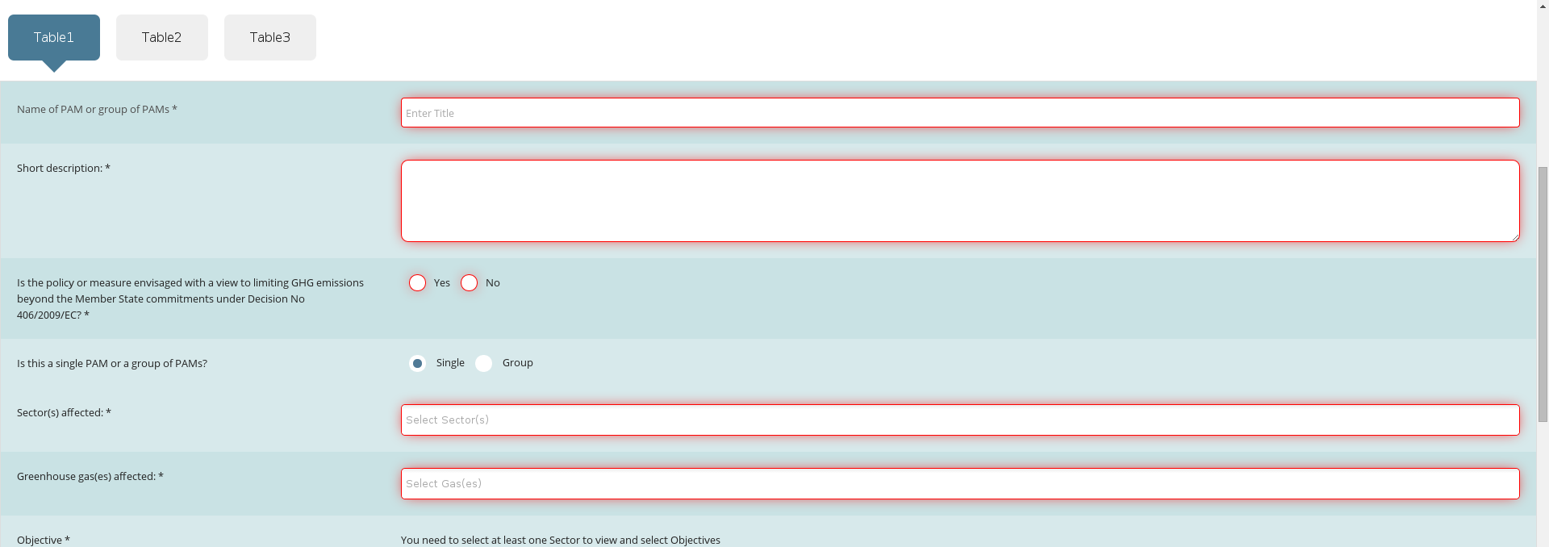

**Add further rows**

It is possible to add multiple rows as an answer to some questions. This can be achieved by clicking the “**Add**” button next to the question field. A new empty row will be added to the table. If you have entered any row accidentally and you want to remove it, then press “**Remove**” button. All the data will be removed in selected row after confirmation.

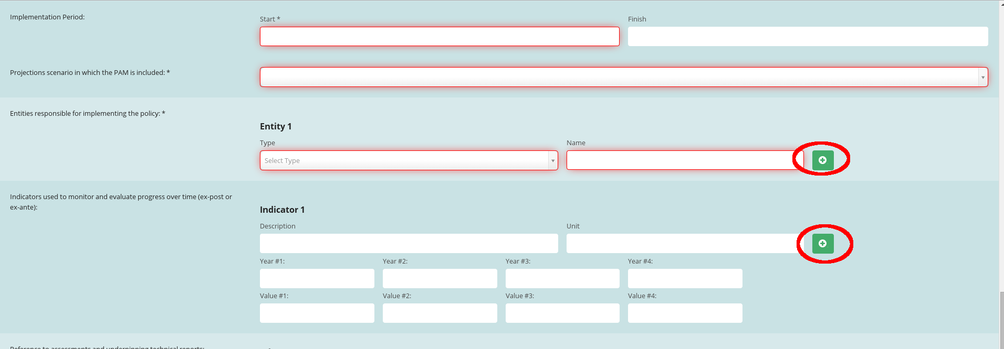

**Multiple answers**

Many Questions allows to select multiple values as an answer to the questions. Click on the "Select" input field to view the relevant values in popup collection choices. Click the value to select it and add it to your selection. Click on the X button next to the selection to remove the value.

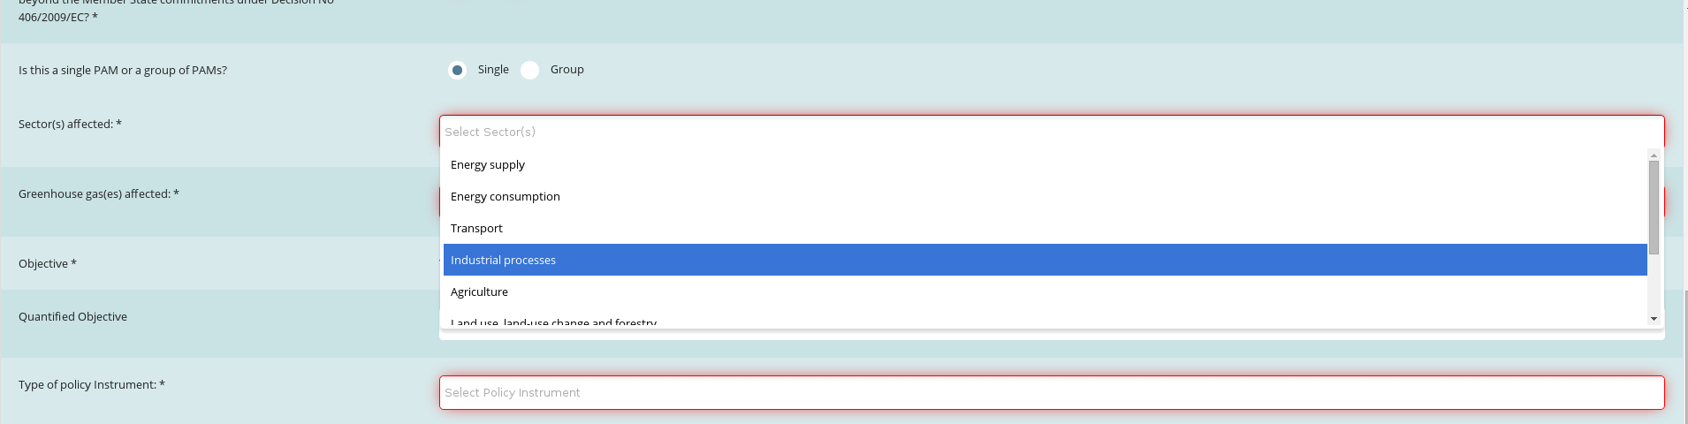

* **Step 6 Save data**

**NB! The online questionnaire does NOT save your changes automatically.** Inserted answers can be saved at any time by clicking on the “**Save**” button in the bottom of the page. The data is saved in XML file (MMR_Annex_XI_questionnaire_1.xml) in CDR envelope. The questionnaire warns you if there are missing mandatory fields or some fields are entered incorrectly. All data is still saved in the envelope, even if they don't pass the validation process.

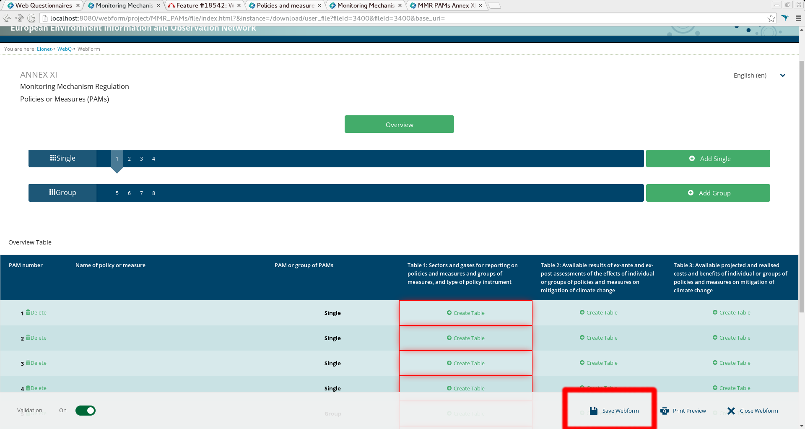

You don’t have to fill in all the questions at one time. You can go back and modify the online questionnaire for completions or amendments later at any time in CDR:

* either by clicking on the “*Modify the MMR Annex XI questionnaire"* link on envelope page
* or by clicking on the corresponding XML file name in the list of files and then clicking on the “*Edit with Web form*” link on document details page

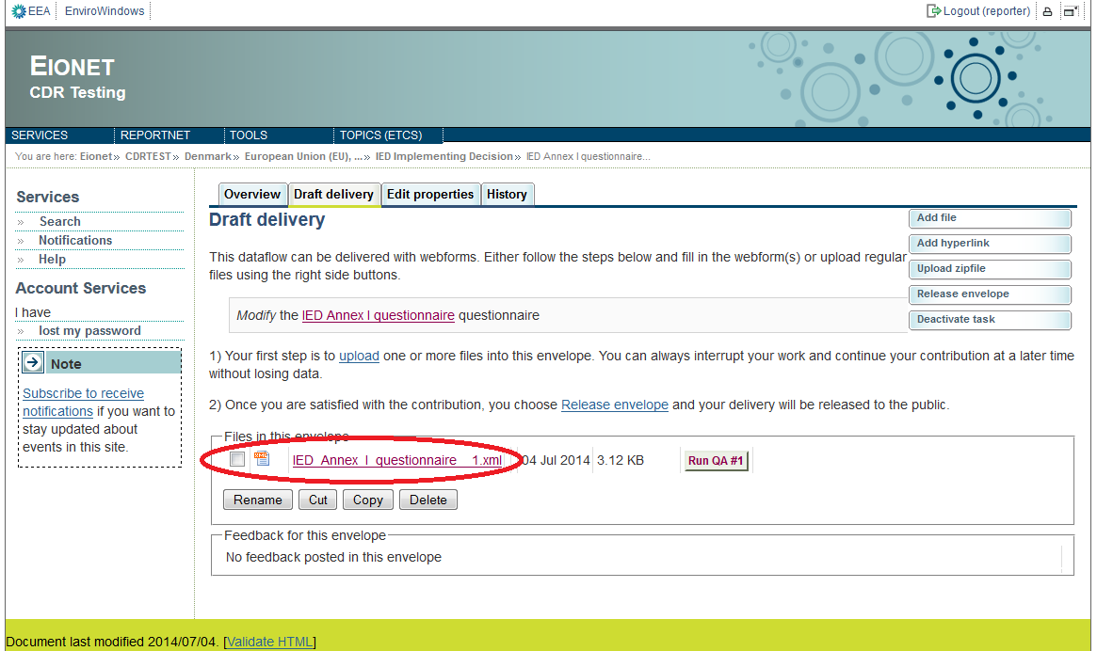

* **Step 7: Upload additional files**

You can upload and submit additional files in the envelope.

You can restrict the uploaded file from public view by ticking the box “*Restricted from public view*”.

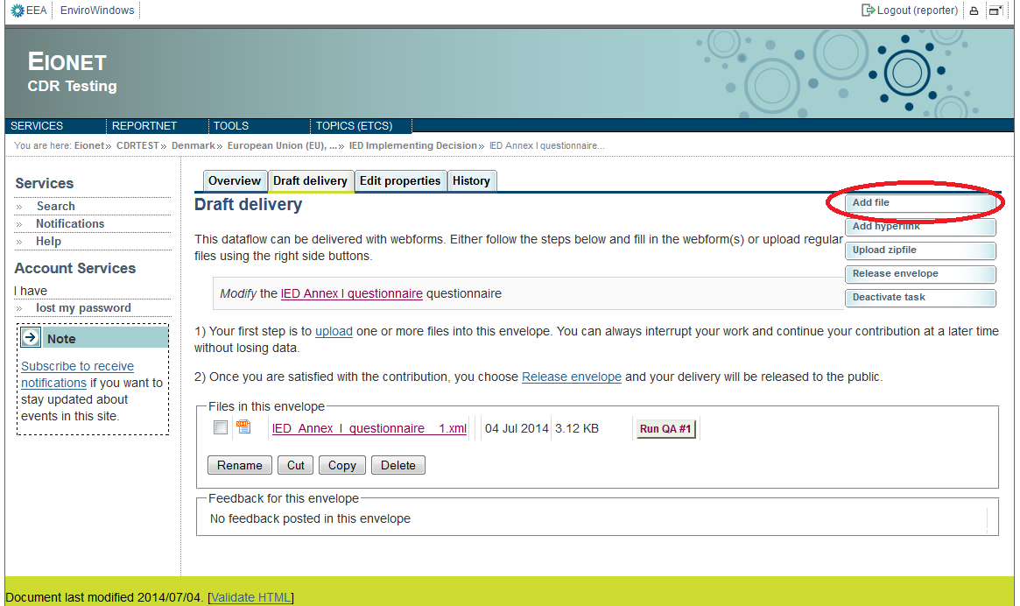

* **Step 8: Download or print out the report (optional)**

You can download or print out the report in CDR. This functionality is available on the document details page. Click on the XML file name in the CDR envelope to open the **Document details** page. All available formats are available at the top of the page in “View file as“ area.

Click on the “**HTML report**” link to download in HTML format or print the report.

Click on the “**Original**“ link to open the raw XML file in your browser.

The Document details page contains also a link to the online questionnaire. Just click on the link “*Edit file with Web form*” if you have found something to change or amend in the answers and you are able to edit all the answers.

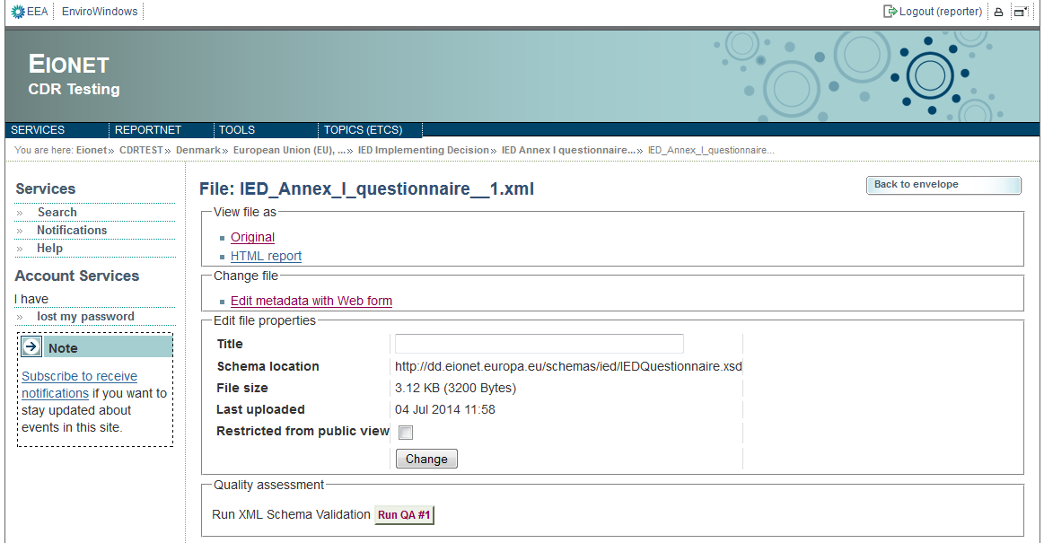

**Example of Print preview:**

**(IMAGE HERE)**

* **Step 9: Complete task**

When you finish the drafting of your work, you need to click on the right side button “**Release envelope**”.

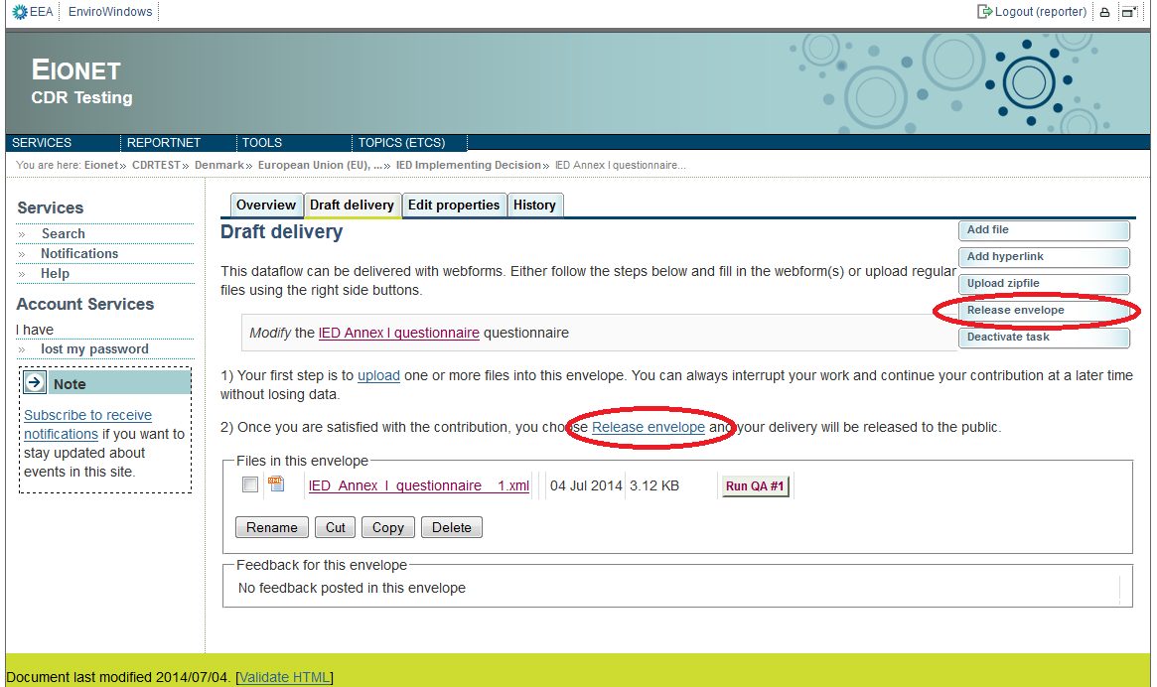

Now the report is submitted and received by the EU and the envelope is available to the public. After a few minutes, confirmation of receipt message and automatic feedback is stored automatically in the envelope's feedback area. Additional feedback might be provided by the Commission or EEA.

The result of the automatic quality assessment contains technical information about the validity of reported data and is useful for data receivers.

# Getting help

CDR help and the reporting manual is available at: <http://cdr.eionet.europa.eu/help>

|  |  |
| --- | --- |
| For technical assistance with access to CDR and the submission process.  Questions related to IED Annex I questionnaire reporting will be forwarded to the technical team. | [helpdesk@eionet.europa.eu](mailto:helpdesk@eionet.europa.eu) |